Rent Review-Regulated and Assured Tenancies

Process Description:
- Regulated Tenancies; Most lettings by private landlords that began before 15 January 1989 are Regulated tenancies. Regulated tenancies are sometimes called “protected tenancies” or “Rent Act tenancies”. Regulated tenants pay a fair rent which is lower than a market rent. A fair rent is set by a rent officer at the Valuation Office Agency. This is the maximum rent that a landlord can charge under the tenancy. Regulated Rent tenancies are subject to rent review every 2 years and can be increased by up to 15%. Grainger currently has approximately 1,740 Regulated tenancies.
- Assured Tenancies: Most tenancies granted on or after 15 January 1989 are likely to be assured tenancies (or assured shorthold tenancies). Full assured tenants have a right to security of tenure. Shorthold tenants have security throughout the fixed term. Assured tenants are not able to apply to the rent officer for a fair rent but pay rents agreed with their landlord. There is no recommended % increase or upper limit specified. Grainger currently has 596 Assured Tenancies (this includes Assured Churchworkers, Key workers. PHA Housing association and Assured Periodic tenancies).
- Succession: Under the Rent Act 1977, as amended by the Housing Act 1988, a Regulated tenancy will pass to the tenant’s spouse, or someone living with the tenant as husband or wife, who will become a Rent Act statutory tenant provided he or she was living with the tenant at the time of his or her death. If there is no such person a member of the tenant’s family who has lived with the tenant for at least two years immediately before the death of the tenant will be able to succeed to an assured tenancy. There can be no more than two successions. If there is a dispute between qualifying family members, the court can decide who shall succeed. Please refer to the separate Billing Requirements Document for more details and for Grainger’s approach to succession which liberally interprets the above Acts to take into consideration tenants who may need to move into long term care facilities.
- A regulated tenant has certain important rights concerning the amount of rent he or she can be charged and security of tenure. With a regulated tenancy:
  - the landlord cannot evict the tenant unless he or she gets a possession order from the courts, and the courts can grant an order only in certain circumstances
  - if the tenant dies his or her spouse will normally take over the regulated tenancy (a family member who has been living in the home can take over an assured tenancy). Please refer to the separate Billing Requirements Document for more details and for Grainger’s approach to succession.
  - either the landlord or the tenant can apply to the rent officer for a fair rent to be registered
  - once a rent is registered it is the maximum the landlord can charge until it is reviewed or cancelled
  - even if a rent is not registered, the landlord can only increase the rent in certain circumstances
  - the tenant may get housing benefit. Grainger currently processed approximately £400k pa in housing benefits for Regulated and Assured Tenants.
  - the landlord is usually responsible for major repairs
  - the landlord, or in some cases the tenant, can ask the local authority for a grant towards certain repairs and improvements.
- Fair rent/Maximum Fair rent: this is a rent which is worked out by a rent officer or rent assessment committee according to the rules in the Rent Act 1977. All fair rents are recorded in the local rent register. Since 1999, the amount by which a rent officer can increase a fair rent has been limited by law. This is known as the Maximum Fair Rent. The Maximum Fair Rent does not apply where the rent officer considers that there has been a change in the condition of the property or the common parts as a result of repairs or improvements carried out by the landlord and that the new rent to be registered would therefore be at least 15 per cent more than the existing rent. In this case, the rent officer will register a fair rent without calculating the Maximum Fair Rent.
Grainger (as Rent Officer) performs an Inspection of the units held under Regulated tenancy. This information is managed and stored on the FSI Concept Evolution system. A 15% increase is normally applied unless there has been major capital investment in the property.
The rent review passes through 3 internal Grainger Approvers before being finalized and registered with the Valuation Office Agency for entry in the local rent register. At this point Grainger issues form RR1 (application for Registration of Fair Rent Letter) along with an RR1 Cover Letter to the VOA. A Section 45 Letter and Section 45(2) form to the tenant notifying them of the proposed rent change. All letters and forms are issued by post with copies manually scanned and stored on the Grainger Document Management System (DMS).
- Right of Appeal: There is normally a right to object to the rent officer’s rent. If this is done, a rent assessment committee will fix the rent. The appeal can be lodged by either the tenant or Grainger via the VOA. Rent changes cannot be processed until the Appeal is complete. Tenants and VOA receive S45 Appeals correspondence from Grainger and the VOA at each stage of the Appeal process. Letters are currently system generated by Grainger where possible to do so. All letters and forms are issued by post with copies manually scanned and stored on the Grainger Document Management System (DMS).
- Agreed Rents: Once rents have been agreed with the VOA, Grainger issues a revised Section 45 Letter and Section 45(2) form showing the revised agreed rents.
Retrospective adjustments may be required after the Appeal process has determined the rent to be charged. This can result in an additional rent charge or a refund backdated to the start of the rent increase date which is entered in the system as a one off charge/credit.
- If the fair rent determined by the rent officer is higher than the Maximum Fair Rent the landlord can increase the rent from the effective date if the tenancy is statutory or the tenancy is protected (ie still subject to an agreement) and the agreement allows for increases.
- If the fair rent determined by the rent officer is lower than the Maximum Fair Rent, the rent officer will register the lower amount as from the effective date.
The landlord cannot charge the tenant more than the amount that is registered by the rent officer. The tenant can get back any money paid over and above the registered rent after the effective date. After the rent is registered the landlord cannot charge more than a fair rent as from the effective date.
Grainger follows the same internal process for Assured Tenancies as the process for Regulated Rents in terms of multi stage approval and communications to Tenants. Form Section 13(2) is issued to Assured Tenants to advise them of the change in rent. The Valuation Office are not involved in the Appeals process which is handled by the County Court system. Any rent adjustments as a result of the Appeal are not backdated.
- The effective date is:
  - where decided by the rent officer- the date when the rent is registered (except that, where it is registered in the three months before the end of the two-year period it is the day after that period ends).
  - where decided by the rent assessment committee-the date of their decision
  - If there is an appeal we carry on charging the tenant the increased rent that the VOA set but when the Tribunals decision is made we follow their effective date and if the date has past we are able to backdate. The effective date that the Tribunal sets is when we can then next increase the rent in 2 years time.
- In the case of statutory tenancies the landlord must serve a notice of increase on a specific Section 13 (S13) notice form . The notice cannot be backdated by more than four weeks. If the tenancy is protected and the agreement does not allow the landlord to raise the rent, he or she cannot do so until the tenancy comes to an end.
- Where there has been an Appeal lodged with the VOA, Grainger can request details of the reason for the VOA decision. This is a standard letter but is issued to the relevant Tribunal which could differ for each case.
- Grainger Trust: it is becoming increasingly common for rent reviews to be performed for Grainger Trust properties (Affordable, Discounted Market Rent and Intermediate Market Rent tenure types). The units have their own standard letter that is issued as part of the rent review process. Currently, the Tenancy progression team produce a report is ran to pick up the relevant units for the Property Manager who will review and provide the increase amount. The relevant letter (each specific for Grainger Lets, one for Shared Owner/Affordable Rents) to the tenant a month in advance advising of the increase and update the system with a new diary one year in advance. The Tenancy Progressor will put the new charge on the system and advise Credit control to adjust direct debit if necessary.
Currently
1. Regulated and assured Rent Reviews are managed off line using excel sheets which are passed between Property Managers, Senior Property Managers, Assistant property managers and Rent Teams. There is no capture of data or automation of the rent change in the Qube system.
2. Correspondence with the Tenant and the VOA is generated automatically from the Qube template using customized templates/form
The following developments were added to the MRI system to deliver Grainger requirements for Regulated and assured Rent reviews but there were still some limitations with this customization.
i) FRD083, RI-1902257, RI-190228, RI-190228-1-to add functionality to RM module-bugs and issues were not resolved as functionality was then moved to CM module.
ii) RI-200117 CM Rent Reviews-to move and update functionality to CM module-see attached excel sheet which documents changes from FRD083 in RM to RI-200117 in CM.

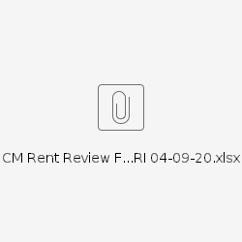

Process Owners:
- Business Process Owner: Phil Nelson
- Subject Matter Expert (SME): Anita Masters
- Business Analyst (BA): Deborah Stein

Process flow:
- Regulated Tenancies
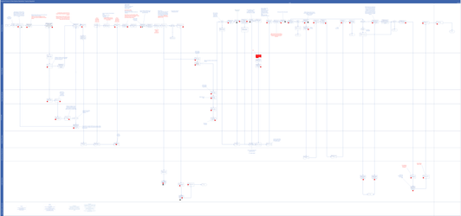
2. Assured Tenancies
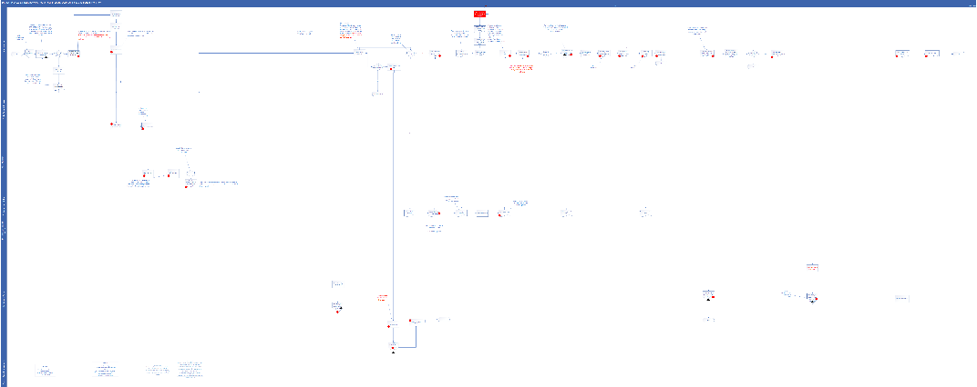

Key rules, definitions, and scenarios
- Limits / thresholds / defaults
- Regulated Tenancies automatically increase every 2 years -a maximum of 15% but can be requested but the final agreed increase is always less than this following negotiation with VOA and/or appeals by tenants.
- Assured Tenancies have no prescribed % increase-each one is individually set by Grainger.
- Calculations / conditions
- Regulated Rents changes can be backdated to the start of the Rent increase date
- Assured Rents changes cannot be backdated but are effective from the date of the agreement to the change.
- Succession of tenants should have no impact on the calculations unless the tenancy is changing from a Regulated to an Assured tenancy.
Succession rules:
- Joint tenancies-The tenancy will continue as a regulated tenancy for the other joint tenant . This doesn't count as a succession. The legal term is 'survivorship'. If the other joint tenant doesn't live there, the tenancy will end
b) Sole tenancies with a partner-tenancy passes to a partner who is living in with the tenant. The tenancy will continue as a regulated tenancy.
c) Sole tenancies with no partner- tenancy can sometimes pass to another family member provided they have lived at the property for at least 2 years . If more than one family member meets this condition, they can decide between them who succeeds to the tenancy. A court can decide if they can't agree.
A second succession will always be to an assured tenancy.
Example: Mr. A was the original regulated tenant. He died and the Tenancy passes to his wife Mrs. A. The tenancy is still Regulated. On the death of Mrs. A the tenancy passes to her daughter who has lived there for 3 years. The tenancy changes to Assured.
4. The Maximum Fair Rent : the calculation is based on the change in the Retail Prices Index since the last fair rent registration was made, plus an additional percentage uplift of 7.5 % for the first time the rent is re-registered after January 1999 or an additional 5% for all subsequent registrations.
- Tables / look-ups
- New tables and fields added to MRI as part of FRD083 Rent Review.
- Scenarios
- PMX-381: The ability to recognize when a tenancy is Regulated or Assured and apply the correct rent review process and uplifts e.g. 15% for Regulated Tenancies and manually entered % for Assured Tenancies.
- PMX-382: The ability to recognize that rent can increase or decrease.
- PMX-383: The ability to flag a unit and alert the business when a rent review is due on a unit.
- PMX-384: The ability to initiate a rent review on a unit and manage the progress of the review and any appeals on the the unit within the system as one single source of truth (no need for off line excel spreadsheets).
- PMX-385: The ability to manage the three tier Grainger approval process on the system with workflows to prompt user action.
- PMX-386: The ability to apply the Grainger internal approval hierarchies to the workflow and approval process.
- PMX-387: The ability to prevent a review from progressing to the next internal approval stage if the previous approval has not been satisfied on the system.
- PMX-388: The ability to track details (reasons, dates) of the Appeals process for Regulated Tenancies or any County Court actions for Assured Tenancies.

- PMX-389: The ability to notify/prompt various teams when the next action in the Rent Review and/or Appeals process is required by workflows.
- PMX-390: The ability to place a rent review ON HOLD
- PMX-391: The ability to auto-generate revised future recurring rent charges for the tenancy.
- PMX-392: The ability to auto calculate and create retrospective adjustments on the tenant account.
- PMX-393: The ability to report all changes and KPIs as required.
- PMX-394: The ability to update the unit with details of when the next rent review is required (based on the completion of the current rent review).
- PMX-395: The ability to capture whether a tenant is paying rent by direct debit
- PMX-396: The ability to automatically update any Direct Debit Payment schedules held in the Salesforce system where the tenant pays the rent by direct debit.
- PMX-397: The ability to mark a review as completed and automatically update the rent review fields for the next review.
- PMX-398: The ability to auto generate documentation and forms from the system with accurate and complete data wherever possible and:
  - store them automatically on the Document Management System.
  - restrict the creation of forms/letters until all relevant conditions/approvals have been satisfied in the process.
  - reprint any forms or letters as required.
Example 1 -RR1:
Regulated Tenancy-Rent review has been completed and will be sent to VOA for registration.
RR1 Form and cover letter are generated as hard copy documentation.
Question 8-should be populated with Y or N if service charges are charged to this unit
Question 9-details of how much rent is due to these service charges should be entered and statement “see attached listing” should be entered on the form.
The details of the service charges should be provided as a separate report which should be derived from the information captured in the Finance system.
The requirements for questions 8 and 9 require new fields to be available on the Rent Review table for the unit so that Grainger Rent Team can select Y/N and add comment to appear on the form.
A new report will also be required to extract the annual service charges that are included in the rent and attached to the RR1 form.
Question 15-should be populated Y or N . If there has been any change in the capital book value of the unit the form should state “see attached listing” and a separate listing detailing the capital expenditure charged to the unit since the last review should be attached.
This will require a separate report to be developed and printed for attachment to RR1.
New fields to be available on the Rent Review table for the unit so that Grainger Rent Team can select Y/N and add comment to appear on the form.
A new report will also be required to extract the capital expenditure since the last rent review to be attached to the RR1 form.
See example documents
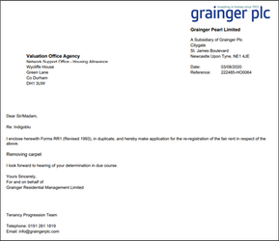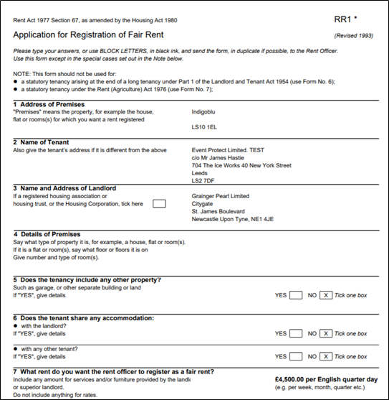


Example 2: Section 45:
Regulated Tenancy-Rent review has been completed and registered with the VOA.
Section 45 letter is generated along with S45(2) form to provide tenant with all details of the revised rent and supporting information.
See example document.
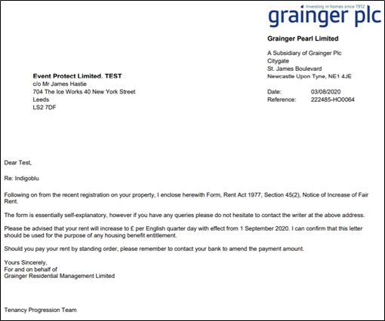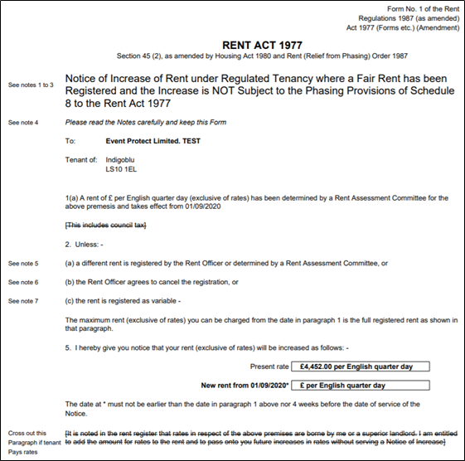

Example3 - Appeal Letter:
Regulated Tenancy-Rent review has been appealed with the VOA.
Appeal Letter/Notice is issued to Tenant
See example document.
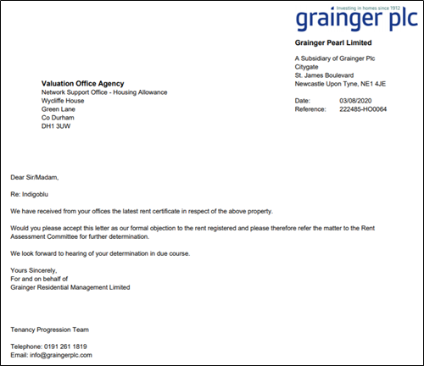
Example 4- Section 13 Letter and Form:
Assured Tenancy-Rent review has been completed.
Section 13 letter is generated to provide tenant with all details of the revised rent and supporting information.
Se example document.

Example 5:- Grainger Trust letter:
The ability to generate a standard letter for Grainger Trust unit rent reviews.
See example document.

Example 6-Tribunal Letter:
Standard letter to the Tribunal requesting reasons for decisions made about rents. This would require users to enter the name and address of the Tribunal as this can differ in each case.

Requirements matrix
The following Jira tickets relate to FRD-083 functionality delivered to date.
RM or CM module (wherever units with tenure type of REG or ASS are held). | https://graingerplc.atlassian.net/browse/CI-11290?searchSessionId=8e01d5d0-f385-4c23-bd67-d109dfabb112&searchObjectId=27101&searchContainerId=10034&searchContentType=issue
New fields and reports to be added to rent review functionality/tables | https://graingerplc.atlassian.net/browse/UAT-910

